Приложение 2
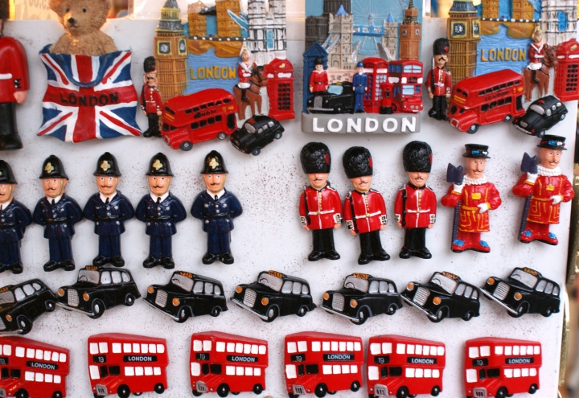 | Could  you live in the  UK?  Manners are usually very important to the British.  Are you polite enough  to live in the United Kingdom?  Try our simple quiz  to find out!

- A friend has invited you for dinner but you are going to be about half an hour late. What do you do?
A You just get there as soon as you can.
B You telephone to apologise and to let you host know when you will arrive.

- You find yourself close to a friend`s house. Do you…
A drop by to see if they are there?
B give them a ring to see if it`s OK for you to visit?

- You friend introduces you to someone at a party. How do you greet them?
A You kiss them on both cheeks.
B You shake hands and say `nice to meet you`.

- The bus arrives just as you reach the bus stop. There is a large queue of people waiting there. Do you…
A run to the front and jump on the bus immediately?
B go to the back of the queues and wait your turn?

