a) | e) 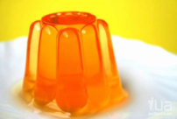
b) | f) 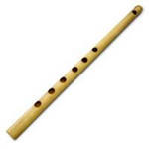
c) 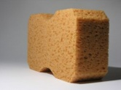 | g)
d)
Jellyfish jam
1. Match the words with the pictures.

- Jellyfish
- Sponge
- SpongeBob
- Dance
- Jelly
- Glasses
- Flute

2. Read and fill in the gaps with verbs in Present Simple Tense.

Sponge Bob _____ (to live) on the bottom of the Pacific Ocean. He lives there in a pineapple house with his pet, Gary. Sponge Bob _____ (to like) to work as a cooker at the Crusty Crab restaurant with his neighbor Squidward. He ______ (to have) two friends. One of his friends _____ (to be) a silly starfish called Patrick. They always _____ (play) together. The second friend, Squirrel Sandy ____ (to be) from earth. Sometimes friends ______ (to gather) together and _____ (to have) fun.

3. Match a character and a picture.

Sponge Bob | Gary | Patrick | Squidward | Mr. Crabs | Squirrel Sandy
 |  | 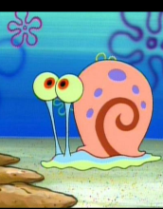 | 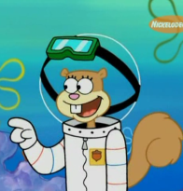 | 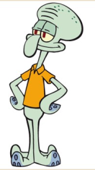 | 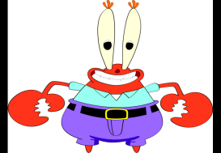

4. Match the word with the definition.

Wild animals  Have fun  Guy  Party is over  Enough  Shake  Fields | a) A friend, a boy.  b) Animals who live in the forest. For example "a bear".  c) A large area of ground covered in grass where team sports are played.  d) When there is a large amount of something.  e) This is the end of the party.  f) Amuse oneself.  g) Move or dance.

Write the necessary form for the following verbs

Present Simple | Past Simple | Translation
Catch |  | ловить
Like | liked
Have |  | иметь
Dance | danced
Be |  | быть
Go | went
Invite |  | приглашать
Start |  | начинать
Shake | shook
Want |  | хотеть
Make |  | делать
Help | helped

5. Tick whether it is true or false (T/F)

1. SpongeBob caught a jellyfish to get jelly for his sandwiches.
2. SpongeBob didn’t like jelly because it wasn’t tasty.
3. SpongeBob had fun with jellyfish.
4. Squidward danced with SpongeBob and jellyfish.
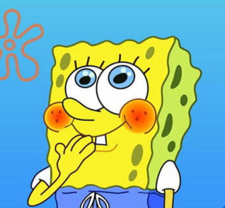
5. When the party was over friends went to bed.
6. At night jellyfish invited friends and they started to dance again.
7. Jellyfish liked the music Squidward played.
- Jellyfish liked the music Gary played.
- Gary shook his hands.
- SpongeBob helped jellyfish to return to jellyfish fields.
6. Complete the sentences to follow the story. Choose the right variant.
1. Sponge Bob caught a) a jellyfish b) a fish c) a butterfly
2. He made a) coffee b) jelly c) soup
2. Jellyfish wanted to play with a) Sandy b) Gary c) SpongeBob
3. Sponge Bob and Jellyfish a) had fun b) watched TV c) read at the Sponge Bob's house.
4. Jellyfish a) helped b) invited c) played friends and they a) danced b) watched TV c) slept all the night.
5. Jellyfish made much a) coffee b) noise c) music
6. Sponge Bob wanted to a) play computer games b) play hockey c) stop the party
7. Jellyfish liked the music a) Gary b) Squidward c) Sandy played.
8. a)SpongeBob b) Patrick c) Sandy helped jellyfish to return to jellyfish fields.

7. Answer the questions.
Do you like jelly?
Would you like to catch jellyfish in the sea?
Can you have fun with a jellyfish?
Would you like to dance all the night?
Who do you have fun with?
When do you have fun?
What is your hobby?

8. How do you have fun? Write your story using the scheme.

I like/don’t like having fun.
I always have fun with…
We usually…
My hobby is…
I think it’s…

Home task.

9. Describe a picture. Use Past Simple Tense.

- 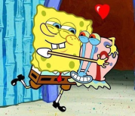 1).................................... (hug)
- 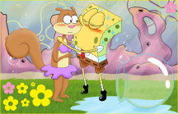 2).........................................(kiss)
- 3).............................................. (catch)
- 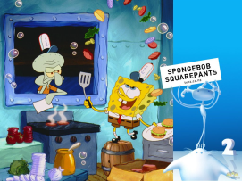 4)......................................... (cook)
5)..........................................(have picnic)
- 6).............................................. (play a guitar)
- 7)............................................. (play football)
- 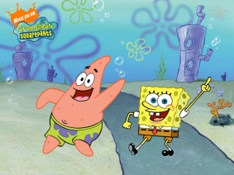 8).................................. (dance)

