Приложение 2

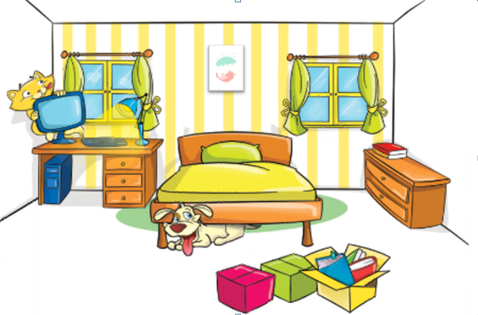 | Put in the prepositions:  on  in  under  over  in front of  behind  between

The bed is the windows.
The dog is the bed.
The lamp is the desk.
The cat is the computer.
The boxes are the bed.
The books are the box.
The poster is the bed.

