Приложение 4

Listen and say : Where is Simon’s room?
- 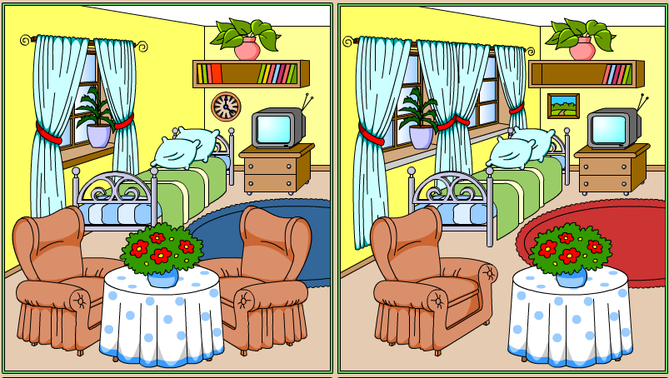

- Put in T (true) or F (false):
1. | There are two books on the shelf.
2. | There is a poster on the wall.
3. | The walls are yellow.
4. | There is a sofa and a table in his room.
5. | There is a blue carpet on the floor.
6. | There is a TV and an armchair in the room.

