Bought me a cat
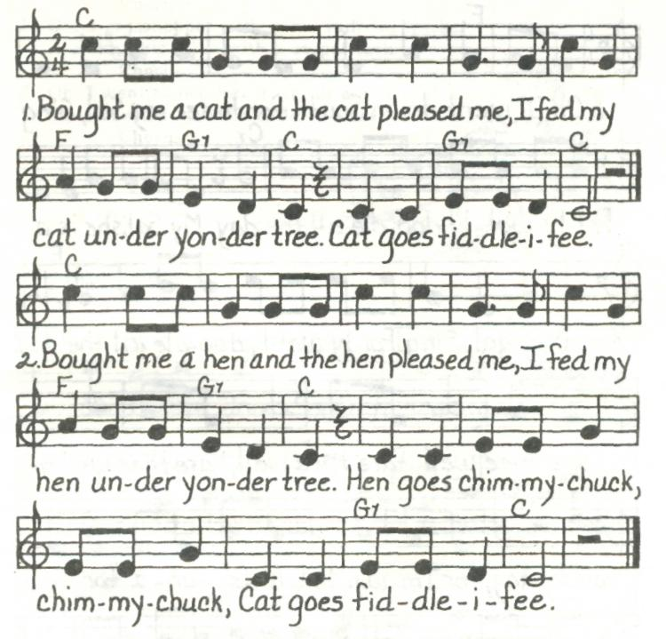
3. Bought me a duck and the duck pleased me,
I fed my duck under yonder tree.
Duck goes quack, quack,
Hen goes chimmy-chuck, chimmy-chuck,
Cat goes fiddle-i-fee.
4. ...goose goes hissy, hissy...
5. ...sheep goes baa, baa...
6. …pig goes oink, oink...
7. ...cow goes moo, moo...
8. ...horse goes neigh, neigh...
9. ...dog goes bow-wow, bow-wow...

