Activity Sheet 1
Match the words in the box with the illustrations.

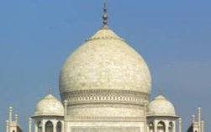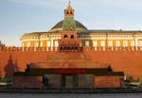
A palace
A dome
A minaret
A mausoleum
A temple
A church

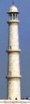
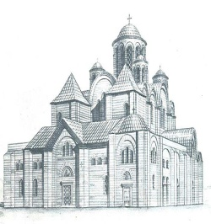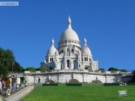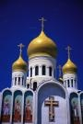

_______________________________________________________________________________

Activity Sheet 2
Listen to the text and tick the correct words √

- a palace

- white marble

- a temple

- a main dome

- four minarets

- Big White Building

- Pakistan

Activity Sheet 3
Сomplete the table with words and numbers from the box.

1. | The Tag Mahal is in … .
2. | It is the Eight … .
3. | The building is made of…
4. | Inside, there are … rooms.
5. | Outside, there is a beautiful garden with …
16
four pools
Agra, India
precious stones
Wonder of the Modern World

________________________________________________________________________________

Activity Sheet 4

Read each statement and decide it is true or not true. If it is, draw a circle around T, if it is not, draw a circle around F.

- The Tag Mahal is in Agra, Pakistan. | T | F
2. It’s not a palace, it’s a mausoleum for a dead wife. | T | F
3. The building is made of red breaks and stones. | T | F
4. There’s a large dome in the centre of the building. | T | F
5. It has five minarets at each corner. | T | F
6. Inside there‘re three floors with 15 beautiful rooms. | T | F
7. In the garden there’re 4 pools. | T | F

________________________________________________________________________________

Activity Sheet 5
Try to make notes under these headings, and then describe the Taj Mahal.

name | place | colour  (materials) | inside | outside

