Приложение № 4

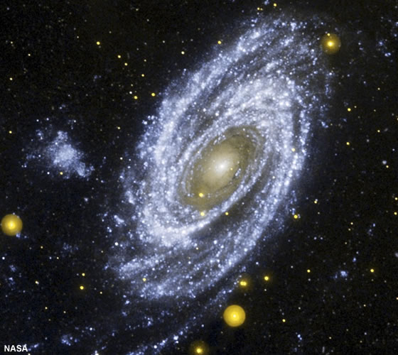
In the day far away we are flying we are flying to the stars in the sky so near to us - and yet so high.

