Приложение 2.
Card1.
Task: Match the descriptions of the animals and the pictures.
1. This animal lives in Australia. It has got a long tail and strong legs. It can jump very well. It likes to eat grass and leaves.
2. This animal is funny. It climbs trees very well. It jumps from tree to tree.
3. This animal lives in the forest. It has got a thick red coat and a long bushy tail. It eats meat as well as fruit and green vegetables. This animal is very clever.
4. This animal lives in the water. It is long. It swims very well. It hunts other animals.
a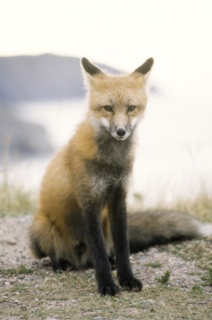b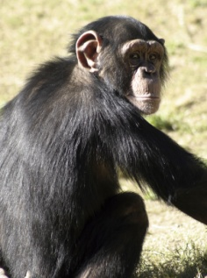c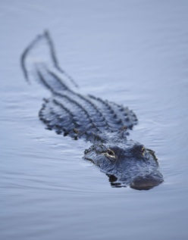d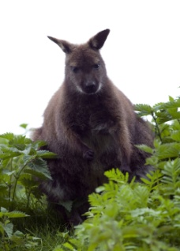
1.____; 2____; 3____; 4____.

Card 2.
Task: Make up a dialogue between the interviewer and Jane and dramatize it. First you should put the lines in the logical order.
1. What wild animals visit your town?
2. What is their habitat in the wild?
3. Where can you see them in your town?
4. Why do they come to the town?
5. Are they dangerous to humans?

a) No, they aren’t dangerous at all. They are funny and friendly.
b) We can see them in the park.
c) I think because people give them food.
d) Squirrels.
e) They usually live in the forest.
1.____; 2.____; 3.____; 4.____; 5.____.
Card 3.
Task: Do the crossword.

 |  |  | 1 | 8
 |  |  |  | 2
3
4
 |  |  | 5
 |  | 6
 |  |  |  | 7

Elephants have got two big __________ on their heads (1).
Giraffes have got very long __________ (2).
Tigers and zebras have got black ___________ (3).
Monkeys can ___________ (4) trees very well.
Kangaroos have got long ____________ (5).
Dinosaurs are not beautiful – they are ___________ (6).
Lions have got _____________ teeth (7).
_____________ (8) are our friends.

Card 4.
Task: Read the text about 2 animals and say true (T) or false (F).
A baby kangaroo is called a joey. When a joey is born, it is very small – only the size of a finger. All kangaroos carry their babies in a pouch at the front of their stomachs. The joeys stay there for about eight months. Kangaroos are very brave mothers. When they, they jump in the air and then kick their enemies.
Penguins are very good parents. The father keeps eggs on his feet for 60 days. He doesn’t eat a thing while they wait for their babies. Afterwards, they feed the chicks from their throats. When the mother penguins come back to their babies, the fathers go to sea to eat and rest.

1. A baby kangaroo is called a pup. ___
2. The mother kangaroo can’t fight. ___
3. All kangaroos carry their babies in a pouch at the front of their stomachs. ___
4. Penguins are very good parents. ___
5. The father penguin keeps eggs on his feet for a month. ___
6. When the mother penguins come back to their babies, the fathers can eat and rest. ___

Card 5.
Task: Fill in the table using such words as long, short, big, small, strong, trunk, no.
parts of the body | elephant | polar bear | dolphin
head |  |  | big
nose |  | big
ears | huge
legs/paws |  | 4 short
tail
teeth |  |  | sharp
eyes | big
claws |  | long

