Приложение 1
The game «Naval battle»
 | use | MP3 player |  | Digital camera | DVD player | E – book device | Robot pet | Headphones | Laptop
I

The kids
My father
They

The teacher
We

 |  |  | Read | Listen | Watch | Surf the Net | Take pictures | Play with it | Store music files

Приложение 2
Самооценка по таблице
1 | Работал активно | 1 | 2 | 3 | 4 | 5
2 | Проверял свою работу | 1 | 2 | 3 | 4 | 5
3 | Работал внимательно | 1 | 2 | 3 | 4 | 5
4 | Выучил новые слова | 1 | 2 | 3 | 4 | 5
5 | Говорил на английском языке | 1 | 2 | 3 | 4 | 5
6 | Помогал однокласснику | 1 | 2 | 3 | 4 | 5
От28 до30 – оценка 5
От 22 до 27 – оценка 4

Приложение 3
Test on line
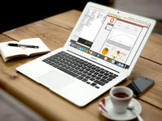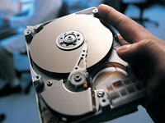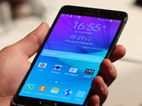
- Laptop Hard drive Electronic path
- Swivel chair VR goggles Mouse
- Tablet Battery Smartphone

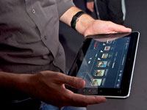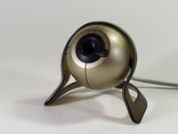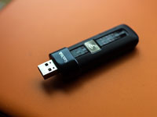
- Net book Remote control Bandwidth
- Tablet PC Webcam Flash drive
- Motherboard Charger Wire

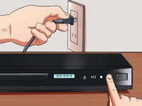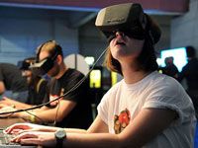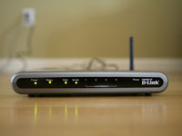
- DVD player Cleaning kit Wi-Fi router
- Cell phone Case Scanner
- Laptop VR goggles Moniter

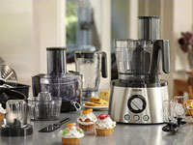
- Food processor
- Keyboard
- Stand
Some works of students
