# Appendix №1

**General levels of superstitious behavior and belief**

**Russia**

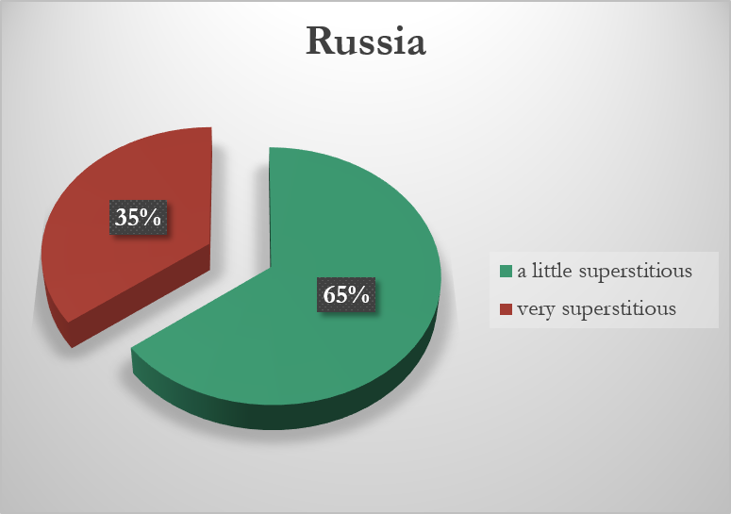

**England**

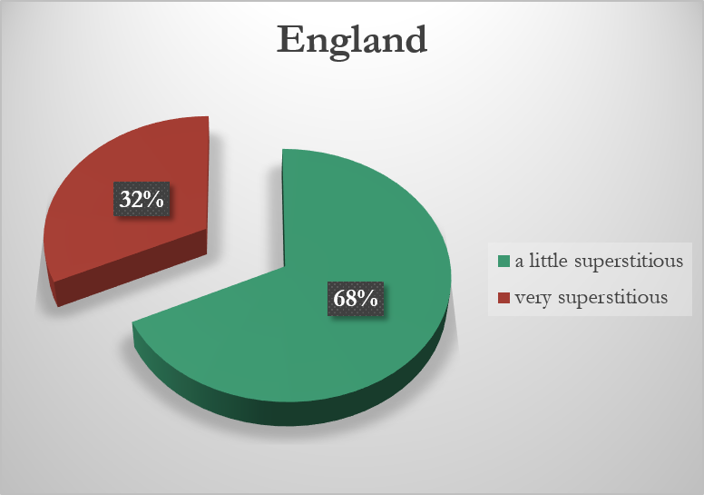

# 

# Appendix №2

**Rank superstition % of people endorsing each superstition**

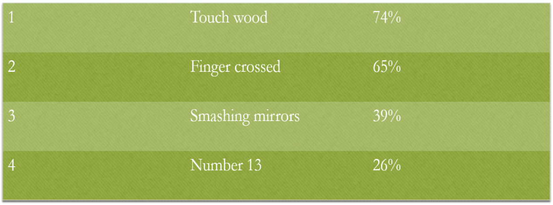

# Appendix №3

**What sort of people are superstitious?**

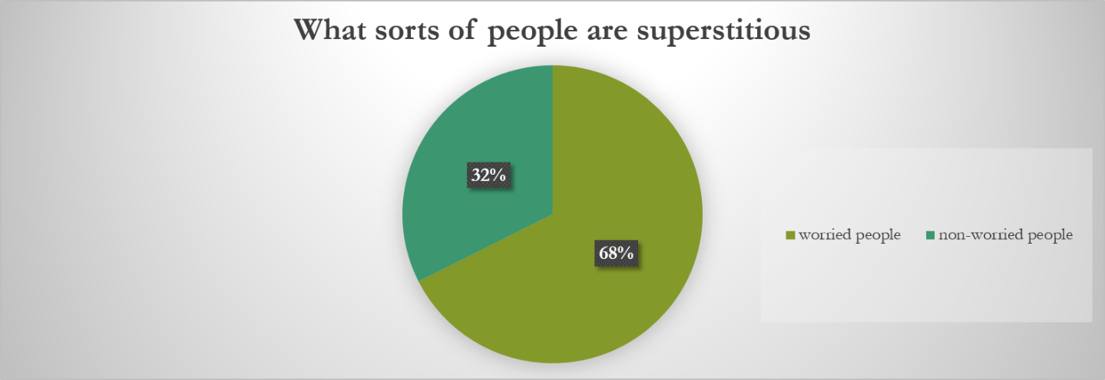

# Appendix №4

**Tests**

**The first test**

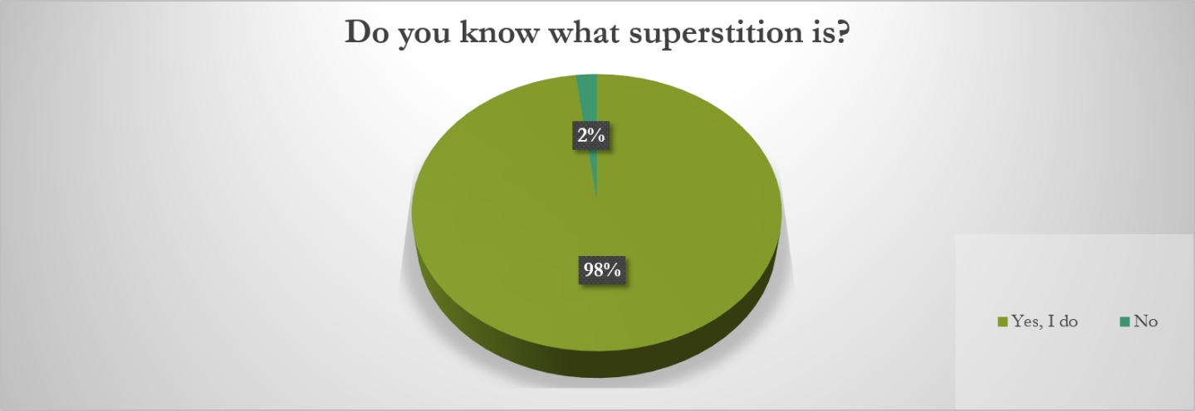

**The second test**

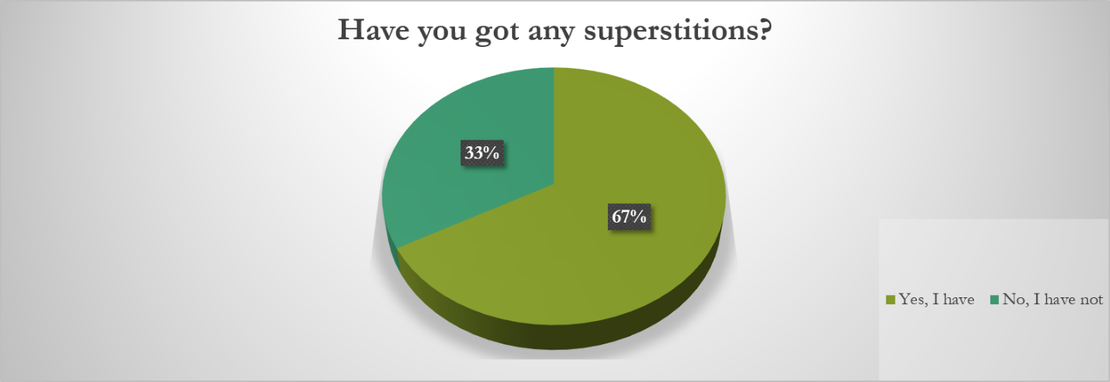

**The third test**

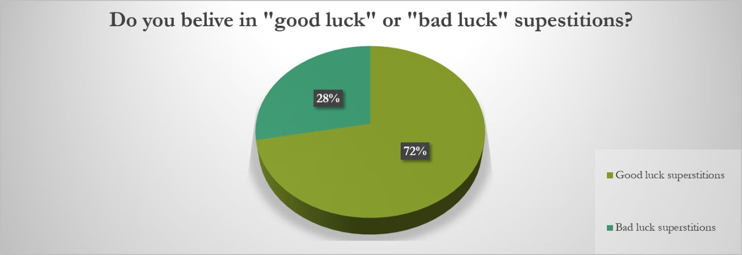

# Appendix №5

**Differences**

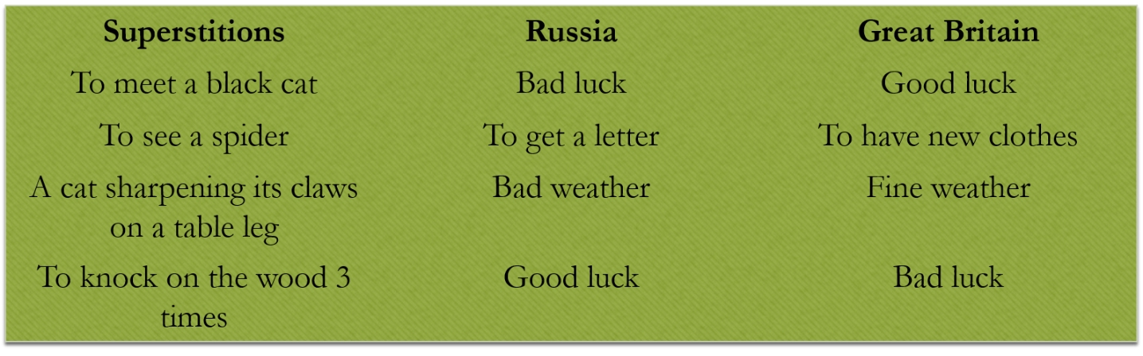

**Similarities**

